**VILNIUS UNIVERSITY**

**KAUNAS FACULTY**

INSTITUTE OF SOCIAL SCIENCES AND APPLIED INFORMATICS

Study programme Information Systems and Cyber Security

**DESIGN STAGE REPORT**

SOFIIA CHEKMENOVA

YEHOR POLIARSKYI

**Team №4**

**Participants:**

Sofiia Chekmenova,

Oleksii Parshyn,

Yehor Poliarskyi,

Stepan Kozlov,

Jaykumar Mathukiya

Kaunas 2023

Table of contents

Functional and Non-functional requirements 4

Design and Functionality 6

UML Diagram 10

Use Case Templates 11

Sequence Diagarams 21

Conclusion 24

**OKR №3, 5-9**

**Aim:**

* The aim is to provide design and functionality of "The secure digital service environment "Purple VPN""; describe functional and non-functional requrments; provide UML Diagram, Sequence Diagarams, Use Case Templates.

**Tasks:**

* Figure out functional and non-functional requirements.
* Describe and show functionality of service.
* Provide UML Diagram
* Provide 5 Use Case Templates.
* Provide 5 Sequence Diagarams.

# Functional and Non-functional requirements

At first, we should find out functional and non-functional requirements. Functional requirements are needed to specify what a system should do, the features it should have, and the behavior it should exhibit. Non-functional requirements define the qualities or characteristics of the system, such as performance, usability, security, and reliability. Here you can observe all requirements:

Functional Requirements:

* User Authentication:

Users must be able to securely log in and authenticate their identity before accessing the VPN.

* Encryption:

The VPN service must provide strong encryption protocols to ensure the confidentiality and integrity of data transmitted over the network.

* Server Selection:

Users should be able to choose from a list of available servers to connect to, providing flexibility and optimizing performance.

* Multi-Platform Support:

The VPN service should be compatible with various operating systems and devices, such as Windows, macOS, iOS, Android, etc.

* Split Tunneling:

The ability for users to decide which traffic should go through the VPN tunnel and which should directly access the internet.

* Kill Switch:

In the event of a VPN connection failure, a kill switch should be implemented to immediately terminate internet access to prevent data leaks.

* Bandwidth Management:

The VPN service should manage bandwidth efficiently to ensure a stable and fast connection for all users.

* Logging Policy:

Define the level of logging the VPN service will perform, ensuring a balance between user privacy and network security.

* Automatic Updates:

The VPN software should have a mechanism for automatic updates to ensure that users are always using the latest security patches and features.

* Dynamic server location:

If VPN software sees that one server is overloaded, it will automatically replace some users to other servers to provide fast internet speed.

Non-functional Requirements:

* Performance:

The VPN service should have minimal impact on network performance, providing low latency and high throughput.

* Scalability:

The architecture should be designed to scale easily as the number of users and network traffic increases.

* Reliability:

The VPN service should have a high level of reliability, with minimal downtime and a robust failover mechanism.

* Security Compliance:

Ensure that the VPN service complies with industry-standard security practices and regulations to protect user data.

* Usability:

The user interface of the VPN software should be intuitive, making it easy for users to configure and use the service without extensive technical knowledge.

# Design and Functionality

All design was made in the tool „Figma“. You can tap on the link and take a more detailed look on our demo-version. Our design was made in purple and black colors, because we thought that it is good combination. Therefore, our VPN service is called „Purple VPN“. The main innovations in our demo versions are: noteworthy features, including an intuitive interface, dynamic server location, and robust data confidentiality, aimed at elevating the user experience.

Link:<https://www.figma.com/file/RSag42TWevDM7l3JddTXwe/Untitled?type=design&node-id=0-1&mode=design>

Overall, there are 5 main buttons on which user can tap. The first one is “Coonect” button. It is used for connecting users to our VPN’s servers. It is located on main menu.



**Figure 1. Connect button**

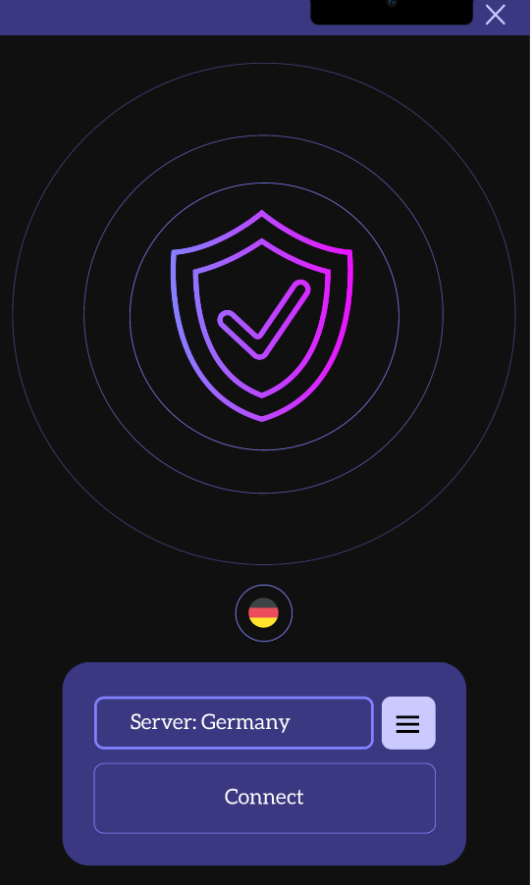

**Figure 2. Main menu**

After connection you see it on the display and you also can see the number of Ping.

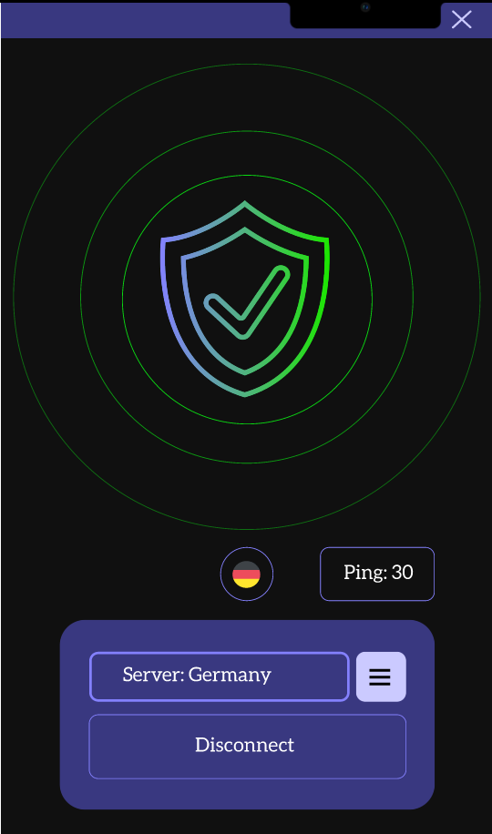

**Figure 3. Connection proccess**

The second butoon is used to open a new page where the user can select and change server.



**Figure 4. Selector**

Here are three servers (Ukraine, Germany and Lithuania) which you can choose.

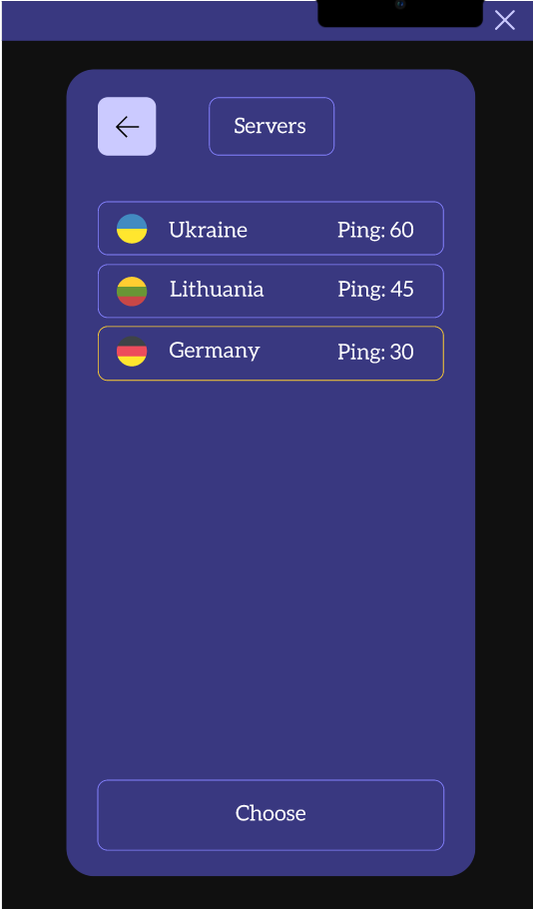

**Figure 5. Servers**

This button is used to back to the main page.



**Figure 6. Return button**

This button is used to choose a server.



**Figure 7. Choose button**

And the last one is “Disconnet” button. It is used to disconnect from VPN’s server. It also located on main menu.



**Figure 8. Disconnect button**

# UML Diagram

Here you can see our UML diagram. There are two actors: user and VPN service. User can register account, choose server location, connect to VPN and get Costumer support. The VPN service can access to all this proccesses, but also it has an opportunity to monitor VPN usage of users. This diagram is simple, but it show brightly main structure of work.

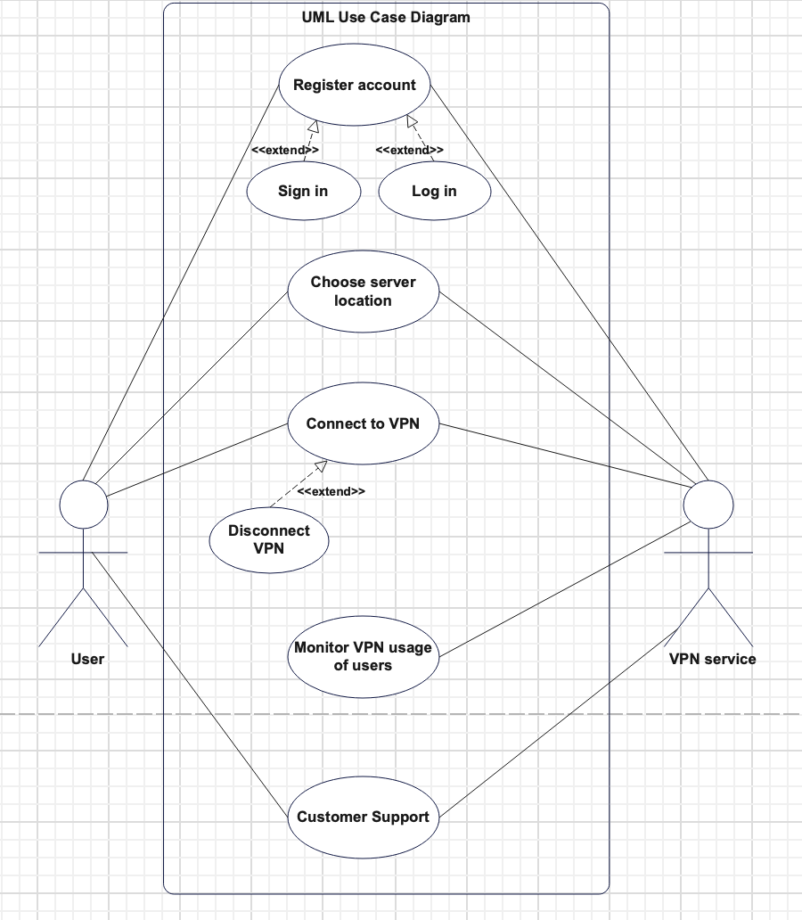

**Figure 9. UML Diagram**

# Use Case Templates

There are 5 Use Case Templates, which were made according to UML Diagram:

|  |  |  |  |
| --- | --- | --- | --- |
| Use Case Identification and History | | | |
| **Use Case ID:** | VPN.T.C.1 | | |
| **Use Case Name:** | Register account | **Version No:** | 1 |
| **End Objective:** | To sign in/log in user account in VPN service | | |
| **Created by:** | Team #4 | **On (date):** | 18/10/2023 |
| **Last Update by:** | Team #4 | **On (date):** | 18/10/1023 |
| **Approved by:** |  | **On (date):** |  |
| **User/Actor:** | User | | |
| **Business Owner Name:** | - | **Contact Details:** | - |
| **Trigger:** | User | | |
| **Frequency of Use:** | Often, users can use the VPN with and without registration. | | |

|  |
| --- |
| Preconditions |
| User should download the VPN app and tap on the “users” page. |

| **Basic Flow** | | |
| --- | --- | --- |
| **Step** | **User Actions** | **System Actions** |
| **1** | User download the VPN app and go to the “users” page. | The system opens a window for logging, where the user needs to write his email and password. |
| **2** | User has entered all the data that was required of him and can use the application for connection to the VPN. | Due to the fact that the user entered his email and password correctly, the system recognized his account and allowed him to connect to the VPN. |

| Alternate Flow | | |
| --- | --- | --- |
| **Step** | **User Actions** | **System Actions** |
| **1** | User download the VPN app and go to the “users” page. | The system opens a window for signing, where the user needs to write his email and password. |
| **2** | User entered all the data that was required of him and waiting for confirmation by email. | The system sent on user’s email confirmation letter. |
| **3** | User has been verified and can use the application for connection to the VPN. | Due to the fact that the user verified himself, the system allowed him to connect to the VPN. |

| Exception Flow | | |
| --- | --- | --- |
| 1 | The user entered wrong mail or password. | The system does not recognize mail or password, so it asks you to enter the correct data again. |
| 2 | Due to an unstable Internet connection, the user was unable to log into the system. | The system ask user to refresh the page and try again to enter the required data. |

|  |
| --- |
| Post conditions |
| 1. User logged into his account, so now he can use VPN service fluently and use paid subscription (if he has such). 2. User signed into account, so now he can use VPN service fluently and buy paid subscription. |

|  |
| --- |
| Includes or Extension Points |
| 1. Sign in (extend). If user doesn’t have account, he can create it by using email and password. This opportunity will expand his ability to use the service. 2. Log in (extend). If user has an account, he can log in by email and password. |

|  |
| --- |
| Special Requirements |
| 1. Language support. 2. Remember user’s email and password in the database. |

|  |
| --- |
| Business Rules |
| 1. VPN application can block account that has suspicious activity. 2. User needs to confirm his identity once every three months. |

|  |  |  |  |
| --- | --- | --- | --- |
| Use Case Identification and History | | | |
| **Use Case ID:** | VPN.T.C.2 | | |
| **Use Case Name:** | Choose server location | **Version No:** | 1 |
| **End Objective:** | The ability to choose server location | | |
| **Created by:** | Team #4 | **On (date):** | 18/10/2023 |
| **Last Update by:** | Team #4 | **On (date):** | 18/10/2023 |
| **Approved by:** |  | **On (date):** |  |
| **User/Actor:** | User | | |
| **Business Owner Name:** | - | **Contact Details:** | - |
| **Trigger:** | User | | |
| **Frequency of Use:** | Always | | |

|  |
| --- |
| Preconditions |
| User should tap on the button “Servers” and choose the best one for him. |

| **Basic Flow** <The optimal or normal ("good day") flow of events. The basic flow of events should describe the events that walk through a successful scenario. The basic flow should not include “and/if scenarios”> | | |
| --- | --- | --- |
| **Step** | **User Actions** | **System Actions** |
| **1** | User tap on the button “Servers”. | The system shows user the available servers (name of the country and its ping). |
| **2** | User chooses the best one according to his requirements. | The server recognized user request and connect him to the desired server. |

| Alternate Flow | | |
| --- | --- | --- |
| **Step** | **User Actions** | **System Actions** |
| **1** | User tap on the button “Servers”. | The system shows user the available servers (name of the country and its ping). |
| **2** | User chooses paid server, but he doesn’t have paid subscription. | The system refuses him and asks to choose another server. |

| Exception Flow | | |
| --- | --- | --- |
| 1 | User select server. | The selected server is unavailable, the system attempts to connect user to an alternative server. |
| 2 | User doesn’t see available servers. | The system displays a message indicating server unavailability. |

|  |
| --- |
| Post conditions |
| User chose required server and then can connect to it and use it. |

|  |
| --- |
| Includes or Extension Points |
| There are no includes or extension points. |

|  |
| --- |
| Special Requirements |
| 1. Provide an option for the VPN service to automatically select the best server location based on the user's geographical location. 2. Display real-time information about server load and performance to help users make an informed decision. |

|  |
| --- |
| Business Rules |
| 1. Users cannot connect to a server location that is already at full capacity. 2. Specialized servers (e.g., streaming-optimized, gaming-optimized) may have limited slots, and users can connect based on availability. |

|  |  |  |  |
| --- | --- | --- | --- |
| Use Case Identification and History | | | |
| **Use Case ID:** | VPN.T.C.3 | | |
| **Use Case Name:** | Connect to VPN | **Version No:** | 1 |
| **End Objective:** | The ability of connection to VPN service | | |
| **Created by:** | Team #4 | **On (date):** | 19/10/2023 |
| **Last Update by:** | Team #4 | **On (date):** | 19/10/2023 |
| **Approved by:** |  | **On (date):** |  |
| **User/Actor:** | The system | | |
| **Business Owner Name:** | - | **Contact Details:** | - |
| **Trigger:** | User | | |
| **Frequency of Use:** | Always, it is the main function of the service. | | |

|  |
| --- |
| Preconditions |
| User downloaded the application, logged to the account and select the server. |

| **Basic Flow** | | |
| --- | --- | --- |
| **Step** | **User Actions** | **System Actions** |
| **1** | User select the server and press on the button “Connect”. | The system saw his request and checked the availability of the server to which the user wants to connect. |
| **2** | User get a message about successful connection. | Due to the fact of the availability of the chosen server, the system can provide stable VPN connection. |

| Alternate Flow | | |
| --- | --- | --- |
| **Step** | **User Actions** | **System Actions** |
| **1** | The user used a VPN and now he wants to turn it off. He presses the button “Disconnect VPN”. | The system saw his request and disconnect him. Then it sends a message “Your VPN connection is disabled”. |

| Exception Flow | | |
| --- | --- | --- |
| 1 | User select the server and press on the button “Connect”. | The system saw his request and checked the availability of the server to which the user wants to connect. |
| 2 | The user gets a message that server is temporarily down. | Display a message informing the user that the VPN service is currently unavailable due to maintenance or technical issues. |

|  |
| --- |
| Post conditions |
| User have stable VPN connection and can use it for his own purposes. |

|  |
| --- |
| Includes or Extension Points |
| 1. Disconnect VPN (extend). User has an opportunity to disable VPN connection in application after using it. |

|  |
| --- |
| Special Requirements |
| 1. Users must provide valid authentication credentials (e.g., username and password) to access the VPN service. 2. The use of strong encryption protocols. 3. The VPN service must establish and maintain a reliable connection to the chosen server location. |

|  |
| --- |
| Business Rules |
| 1. The VPN service must be compatible with various devices and operating system. 2. Servers in the VPN network must be authenticated to ensure they are legitimate and not malicious. |

|  |  |  |  |
| --- | --- | --- | --- |
| Use Case Identification and History | | | |
| **Use Case ID:** | VPN.T.C.4 | | |
| **Use Case Name:** | Monitor VPN usage of users | **Version No:** | 1 |
| **End Objective:** | To monitors user VPN usage, including connection time, data usage, and server load. | | |
| **Created by:** | Team #4 | **On (date):** | 19/10/2023 |
| **Last Update by:** | Team #4 | **On (date):** | 19/10/2023 |
| **Approved by:** |  | **On (date):** |  |
| **User/Actor:** | The system | | |
| **Business Owner Name:** | - | **Contact Details:** | - |
| **Trigger:** | The system | | |
| **Frequency of Use:** | Often | | |

|  |
| --- |
| Preconditions |
| The preconditions ensure that the monitoring process is conducted responsibly, legally, and ethically, while also ensuring the accuracy and reliability of the collected VPN usage data. |

| **Basic Flow** | | |
| --- | --- | --- |
| **Step** | **User Actions** | **System Actions** |
| **1** | Users use VPN service fluently, when they want and as the want. | The monitoring system (part of the VPN service) starts collecting VPN usage data from active VPN servers and user devices (user connections and disconnections, bandwidth usage, server usage metrics etc.) |

| Alternate Flow | | |
| --- | --- | --- |
| **Step** | **User Actions** | **System Actions** |
| **1** | User requests customized analysis. | System receives custom analysis request and extracts the data based on mentioned criteria. |
| **2** | User get all required information. | System sends a message about successful gathering information. |

| Exception Flow | | |
| --- | --- | --- |
| 1 | User requests customized analysis. | System receives custom analysis request, but this type of user can’t get information, which he required. The system sends a message about insufficient authority. |

|  |
| --- |
| Post conditions |
| The system has successfully analyzed the VPN usage data, generating insights and reports based on the collected information. |

|  |
| --- |
| Includes or Extension Points |
| There are no includes or extension points. |

|  |
| --- |
| Special Requirements |
| 1. The system should support real-time monitoring capabilities. 2. The monitoring process must comply with relevant data protection and privacy regulations, such as GDPR, HIPAA, or regional data privacy laws 3. The system must support configurable alerts and notifications based on specific criteria, such as unusual user behavior, server overload, or security threats |

|  |
| --- |
| Business Rules |
| 1. VPN usage data, both in transit and at rest, must be encrypted to protect it from unauthorized access. 2. Monitoring VPN usage is permissible only for users who have given explicit consent for their activities to be monitored |

|  |  |  |  |
| --- | --- | --- | --- |
| Use Case Identification and History | | | |
| **Use Case ID:** | VPN.T.C.5 | | |
| **Use Case Name:** | Customer Support | **Version No:** | 1 |
| **End Objective:** | Help users in situations where outside intervention is needed | | |
| **Created by:** | Team #4 | **On (date):** | 19/10/2023 |
| **Last Update by:** | Team #4 | **On (date):** | 19/10/2023 |
| **Approved by:** |  | **On (date):** |  |
| **User/Actor:** | User | | |
| **Business Owner Name:** | - | **Contact Details:** | - |
| **Trigger:** | User | | |
| **Frequency of Use:** | Sometimes | | |

|  |
| --- |
| Preconditions |
| 1. The user cannot solve the problems himself, so he needs the help of the support service. 2. For some reason, the user’s VPN has not been connected for several days. 3. The user cannot sign up for a paid subscription. |

| **Basic Flow** | | |
| --- | --- | --- |
| **Step** | **User Actions** | **System Actions** |
| **1** | The user encounters an issue or has a query related to the VPN service and contacts customer support | The system queues the user's call or chat session and notifies available customer support representatives. |
| **2** | The user explains the issue or inquiry to the customer support representative. | The Customer Support analyzes the issue and provides troubleshooting steps, solutions, or relevant information to the user. |

| Alternate Flow | | |
| --- | --- | --- |
| **Step** | **User Actions** | **System Actions** |
| **1** | User has question about VPN service, so he contacts customer support. | Unfortunately, there are no available support representatives. The system sends a message about it. |
| **2** | User got a message and sends a request to join the queue. | The system recognizes his request and joined him to the queue. |

| Exception Flow | | |
| --- | --- | --- |
| 1 | User has a question about VPN service, so he contacts customer support. | Due to unstable internet connection of user, the system hasn’t seen his request. |

|  |
| --- |
| Post conditions |
| 1. <What is true of the system when the flow of activities finishes> |

|  |
| --- |
| Includes or Extension Points |
| There are no includes or extension points. |

|  |
| --- |
| Special Requirements |
| 1. Support should be accessible through multiple channels such as phone, email, live chat. 2. Language support. 3. Customer support services should be available 24/7 |

|  |
| --- |
| Business Rules |
| 1. Define specific response time standards for different types of user inquiries. 2. Implement a system to prioritize support tickets based on the nature and impact of the issue. 3. Ensure the knowledge base is kept up-to-date with accurate information, troubleshooting guides, and FAQs. |

# Sequence Diagarams

There are 5 Sequence Diagarams, which were made according to the Use Case Templates. They show information in more graphical way.

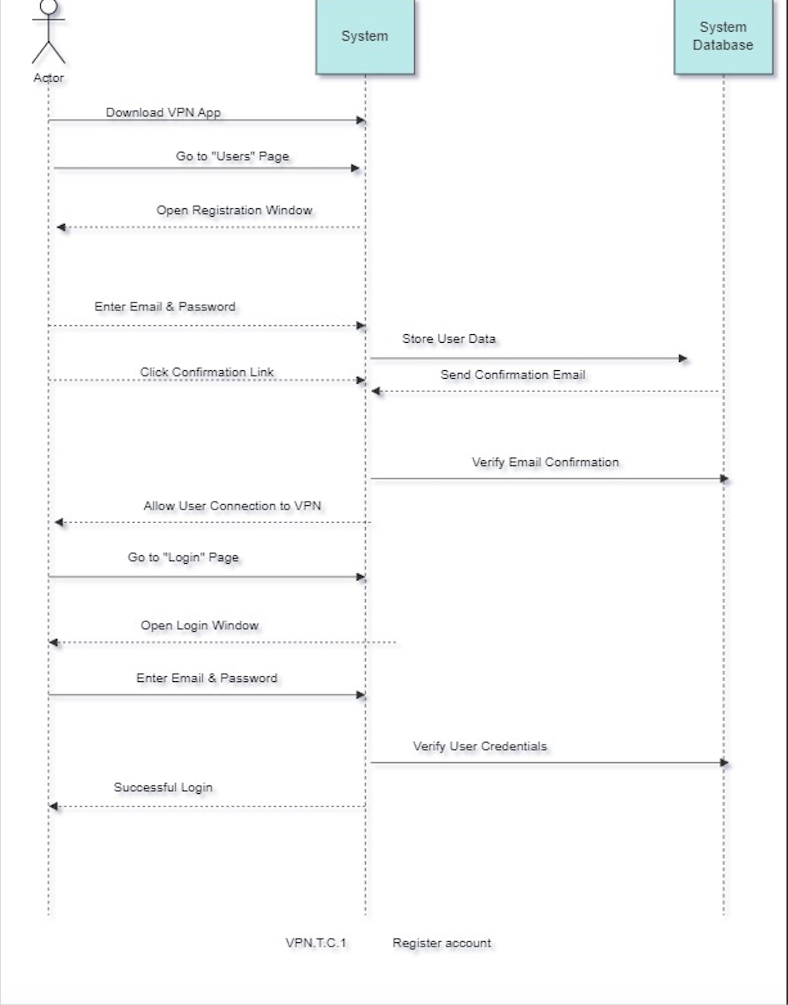

**Figure 10. Sequence Diagaram Register account**

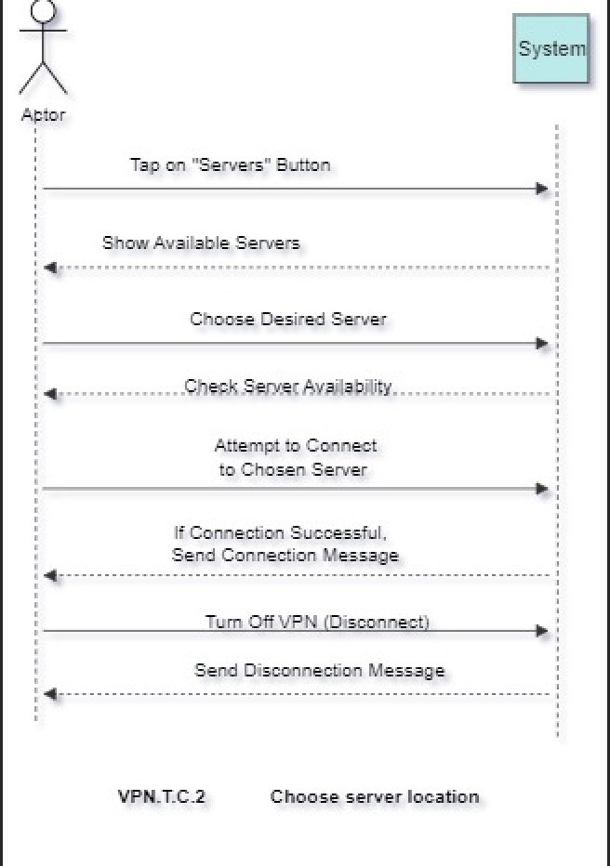

**Figure 11. Sequence Diagaram Choose server location**

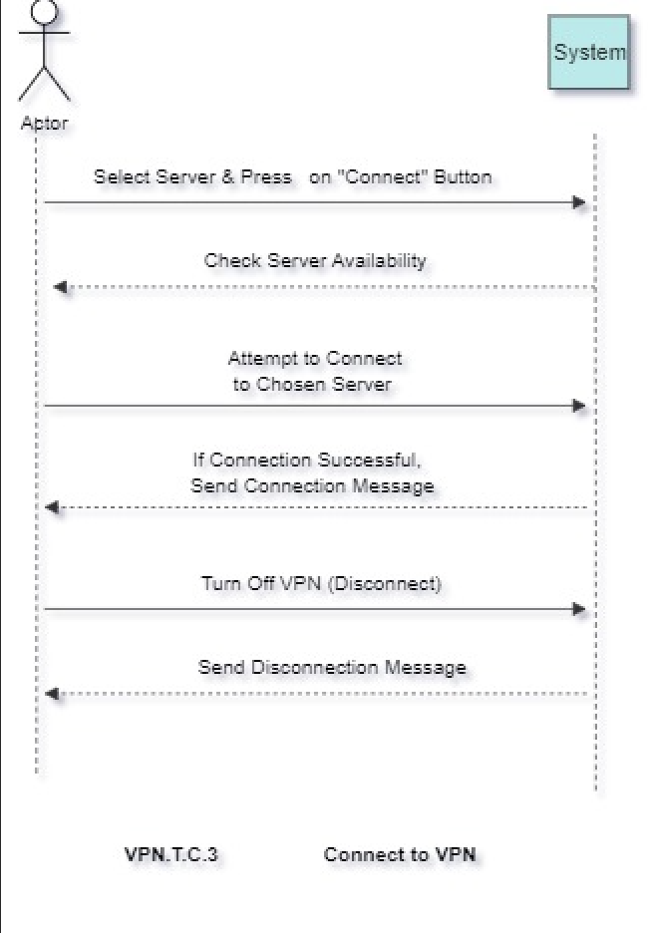

**Figure 12. Sequence Diagaram Connect to VPN**

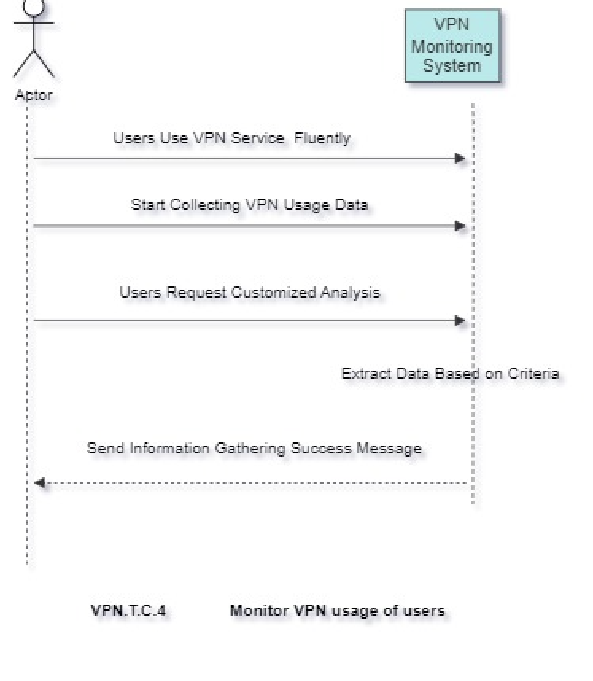

**Figure 13. Sequence Diagaram Monitor VPN usage of users**

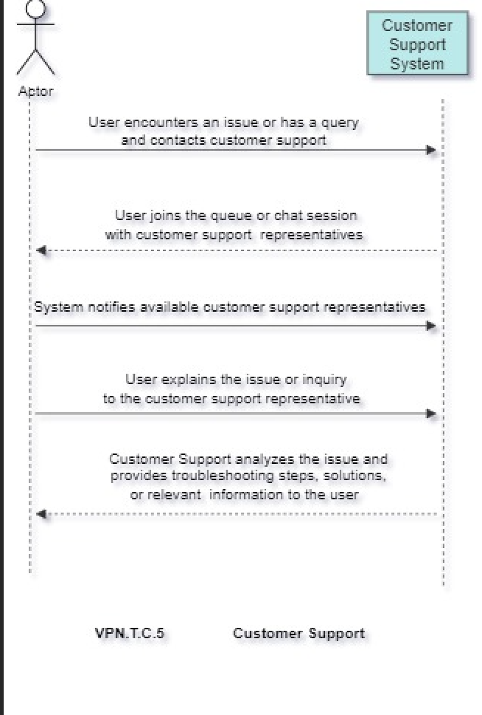

**Figure 14. Sequence Diagaram Costumer Support**

# Conclusion

To sum it up, our goal was to explain how "Purple VPN" works and what it needs to do (functional and non-functional requirements). We successfully outlined its features, showing how it operates and what it can achieve.

We didn't just talk about it – we provided visual aids like UML diagrams, including Sequence Diagrams and Use Case Templates, to make things clearer. These diagrams help everyone understand how "Purple VPN" functions and how different parts work together.